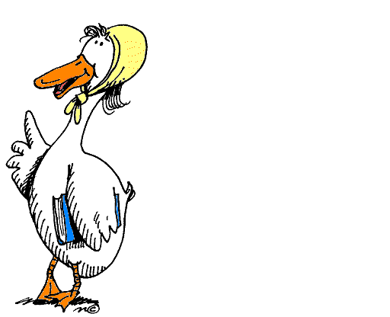

**Mother Goose Preschool**

|  |  |
| --- | --- |
| * Classes follow the Alpine School District calendar * 4-year-old class, children need to turn 4 by September 1st * 3-year old class, children need to turn 3 by September 1st. Must be potty trained. | * $120 per month for MWF classes & $110 per month for T/TH classes (due the first of each month, except September see below) * September (non-refundable) Tuition for 2020 is due by July 1st * All Field Trip fees and performance fees are included * $60 Non-Refundable Deposit Fee (due with registration) |

|  |  |
| --- | --- |
| To secure your spot, please return the form below with $60 NRD materials fee to:  Karen Daniels, 343 W 2600 N  Lehi, UT 84043 | Please feel free to call me or e-mail me with questions.  Cell: (801) 360-1048  Email: [mothergooseprek@gmail.com](mailto:mothergooseprek@gmail.com) |

Thank you for the opportunity to teach your precious child!

**Registration 2020-2021**

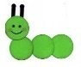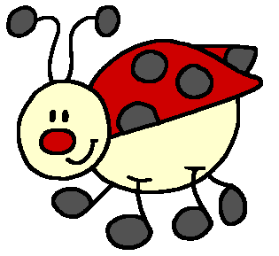

**□ Butterfly class □ Caterpillar Class □ Bumblebee class □ Ladybug class**

**(4 yr. old) (4 yr. old) (3 yr. old) (3 yr. old)**

**MWF 9-11:30 MWF 11:45 - 2:15 T/TH 11:45 - 2:15 T/TH 9- 11:30**

|  |  |  |  |  |  |  |  |  |  |  |  |  |  |  |  |
| --- | --- | --- | --- | --- | --- | --- | --- | --- | --- | --- | --- | --- | --- | --- | --- |
| Student Name | |  | | | | | | | Mark One:  **□**Boy **□**Girl | | | | Birthdate | |  |
| Street Address | |  | | | | | | | | | City |  | | | |
| Mom | | | | | | | Dad | | | | | | | | |
| Name |  | | | | | | Name |  | | | | | | | |
| Cell |  | | | | | | Cell |  | | | | | | | |
| Email |  | | | | | | Email |  | | | | | | | |
| Emergency Contact | | | | | | | Friend or Neighbor | | | | | | | | |
| Name |  | | | | | | Name |  | | | | | | | |
| Phone |  | | | | | | Phone |  | | | | | | | |
| Allergies or Special Concerns | | | |  | | | | | | | | | | | |
| Doctor Name and Phone | | | |  | | | | | | | | | | | |
| Dentist Name and Phone | | | |  | | | | | | | | | | | |
| Insurance Information | | | |  | | | | | | | | | | | |
| Number of Children in Family | | |  | | Position Among Children |  | | | | Right or Left Handed | | | |  | |
| Favorite Food | | |  | | | | | | | Favorite Color | | | |  | |
| Favorite Thing  to Do | | |  | | | | | | | | | | | | |